Aru Grupp AS
INSTALLATION INSTRUCTIONS FOR STAIRS

- The drawings included with the staircase kit sold by Aru Grupp AS:

3D drawing Top view drawing of a staircase

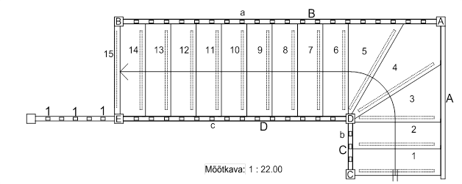
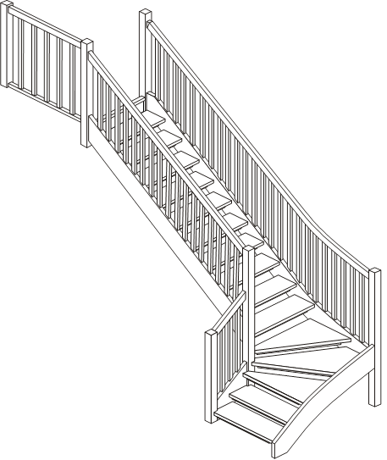

- Equip yourself with the tools and materials to install the stairs:
- Cordless drill
- Standard graphite pencil
- Wooden cages Ø4 mm, Ø5 mm, Ø8 mm ja Ø14 mm for cork holes
- Handsaw
- Hammer
- Plumb bob
- Silicone

- Personal protective equipment required for stair installation:
- Work gloves
- Safety glasses

- Inspect the staircase components strictly based on the staircase parts list!
- Check the completeness of the staircase based on the included top view drawing.
- The part number is located in a visible place. If the part is missing, notify the manufacturer as soon as possible. Preferably within 48 hours.

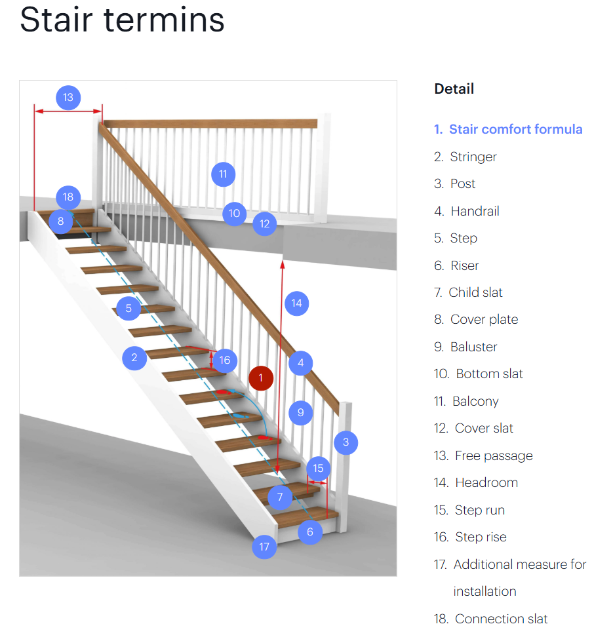

- Staricase assembly
- Fix the steps to the stringer with 5x80 screws and polymer mass must be added to provide additional strength.
- Fix the posts to the stringer and handrail with 5x120 screws.
- Fix the toeboards to the step with 4x50 screws.
- Fix the balusters into te dowels using plymer adhesive.

- Stair installation
- Fix the wall-mounted stringer to the wall’s load-bearing structure using screws at intervals of no more than 1000 mm.
- The stair platform structure must be anchored to the wall at minimum of two points.
- It is recommended to place the included cardboard between the stringer and the wall to prevent creaking caused by contact between different surface finishes.
- Always fix the 2nd floor guardrail post to the wall with screws.
- If possible, fix the base bar to the floor.

- Finally
- All screw holes must be closed with caps.
- Each object has its own space solutions and installation options. This guide introduces you to the basic working methods for installing wooden stairs manufactured by Aru Grupp AS.

Valid from 30.04.2025

